Integrated Language and Workforce Training: PrePost Test

Student name: ________________________________
Student ID number: ___________________________
Date: _______________________________________

Section | Time | Results
Vocabulary | 15 minutes | /22
Reading 1 | 15 minutes | /10
Reading 2 | 15 minutes | /13
Document use | 15 minutes | /12
Reading total | 45 minutes | /35
Listening 1 & 2 | 15 minutes | /13
Job interview  listening | See Speaking below | /6
Listening total |  | /19
Writing | 30 minutes | /20
Speaking | 10-15 min. per student | /15

Integrated Language and Workforce Training: PrePost Test
Vocabulary (15 minutes)
- Match the vocabulary words with the correct definition. The first one has been done as an example
b duty | - A time plan for doing activities.
____ seasonal | - Something that is done as part of the job.
____ schedule | - Someone who tells employees what to do. A boss.
____ supervisor | - Needed during a specific time of the year.
____ strength | - A quality that makes someone good at their job.

- Match the vocabulary words with the correct definition.
____ work history | - The supplies you need to do a job safely (like a hard hat)
____ hazard | - An unexpected and bad thing that happens.
____ regulation | - A rule that tells you what you can and cannot do.
____ incident | - The story of all the places where you worked.
____ Personal Protective  Equipment | - A danger or risk.

- Match the computer vocabulary words with the correct definition.
____ Enter | - to move up or down on a Web page or computer screen.
____ Click on | - a highlighted word (usually blue). If you click on it with your mouse, you go to another web page.
____ Scroll | - to type in words or data (etc.) on a computer.
____ Hyperlink | - to press a button on a mouse to make something happen on the computer.

_____/13
- Tim and Dawn are two managers in a company that sells computers. They are deciding whether they should hire Kevin. Fill in the blanks in the dialogue below. Use the words in the box. The first one is done as an example.

skills | temporary | qualifications | available | handle
hire | employee | entry level | certificate | independent

Tim: I really think we should _________Kevin. He is such a friendly guy. And I think he can do the job.
Dawn: Well, I agree that he has the skills . But I don’t think he has the _________________. He doesn’t have a diploma, or a _________________ or even any courses in anything to do with computers.
Tim: I still think he would be a good ________________. He knows a lot about computers. Don’t forget that this is just an ____________________ job. It’s the lowest level job in the area.
Dawn: You’re right. Also, it’s just a _______________ position. It is only for six months.
Tim: Yes. I think he can _____________ it.
Dawn: Yes. I do, too. He is quite _______________. I mean, he won’t need a lot of help from anyone. He works well on his own.
Tim: OK. Well, let’s phone him and see if he is ______________ to start right away.

_______/9
Reading 1 (15 minutes)
Read the following job posting. Then answer the questions on the next page.

Home Health Care Worker
Employer:
Chartwell Care Homes
Job details:
Salary: $16.10 hourly for 40 hours per week
Hours: Permanent Full-time. Day, Evening, Weekend, Shift
Start date: As soon as possible
Location: 8725 207 Street, Edmonton, AB

Job Requirements
Languages
English
Education
Secondary (high) school graduation certificate
Credentials
First Aid Certificate; Health Care Aide Certificate
Experience
7 months
Specific skills and duties:
Provide personal care; Plan diets and menus; Wash clothing and household linens; Help feed and bathe clients; Give medications.

How to apply
By email: resumes.chartwell@gmail.com

Answer the following questions about the job posting.

- Where is this job located? ____________________________________________
- When does this job start? _____________________________________________
- What level of education is required? ____________________________________
- Do you need experience to get this job? (Circle) YES or NO
- Name three duties or skills of this job:
- __________________________________
- __________________________________
- __________________________________
- How should you apply for this job? _____________________________________
- What language is needed for this job? ___________________________________
- How much does this job pay? _________________________________________

__________/10
Reading 2 (15 minutes)
Read the following job profile. Then answer the questions on the next page.

Autodetailer
What do autodetailers do?
Autodetailers clean and fix up the inside and outside of cars and trucks. They can work in car washes. They can work for insurance, rental, and trucking companies.
Meet an autodetailer
Jerry is an autodetailer. He works for a car rental company.

Here are things that Jerry does:  - He hand washes vehicles.  - He waxes vehicles.  - He cleans under the car, the engine, the tires.  - He cleans the inside of the car, including the seats.  - He cleans out the vents and small spaces.  - He cleans the carpets.  - He removes stains.  - He repairs dents and scrapes.  What is Jerry’s work like?  Jerry works an 8-hour shift on weekdays. Sometimes he works on weekends.  He often has to do the same thing over and over. He needs to be strong and careful. Sometimes he has to carry heavy things. These things can weigh up to 20 kilograms. Sometimes he works with chemicals. | Do you want to be an autodetailer?  - You must be able to lift and carry heavy equipment.  - You need to be able to bend, kneel, crouch, and work in small spaces.  - You need to pay attention to details.  - You need to work with perfumes and chemicals.  - You must look clean and neat.  What education do autodetailers need?  - There are no education requirements to be an autodetailer. But you should have a driver’s license and a good driving record.  - Some people are trained on the job. They may take short courses on the chemicals to use.  What can autodetailers do in the future?  Autodetailers with experience may become supervisors or autobody technicians.  How much does an autodetailer make?  An autodetailer makes between $14.53 and 19.65 an hour.
Answer the following questions about the Job Profile.
- What is the name of the job in this profile? _______________________________
- Where does Jerry work? ______________________________________________
- Name three things Jerry does at work.
- ____________________________________________
- ____________________________________________
- ____________________________________________
- When does Jerry work? _________________________________________________
- Name two skills you need to do this job.
- _____________________________________________
- _____________________________________________
- Do you need healthy knees and a healthy back for this job? (Circle) YES or NO
- What qualifications you need to do this job? (circle one)
- A high school education
- A health and safety certificate
- A driver’s license
- How much money does this job pay? ______________________________________
- Name two other jobs that an experienced autodetailer might do.
- ___________________________________________
- ___________________________________________

_______/13
Reading and Document Use (15 minutes)

Instructions: Salah wants to apply for a job. Read her story.

Salah’s Story
Salah Kadija Seid is a newcomer to Canada. She is 18 years old. She came to Edmonton last year. She lives with her parents in Edmonton. Her address is 10853 106 Street, T6K 2M5. Her home phone number is 780-930-7256. She doesn’t have any other phones. Her email account is Sall3333@gmail.com.
Salah would like to get a job so she can have her own cellphone and buy her own clothes. Salah’s friends call her Sally – and that is what she likes to be called. She hopes to get a job at Starbucks where her friend Mary works.
Salah goes to high school so is not available in the daytime on school days. She can work any evening, but not on Friday when she goes to the mosque with her family. She can also work any time on Saturdays and Sundays. Salah’s parents won’t let her work too late at night. They also said that she can only work 5-10 hours per week. They want her to do well in school.
Mary told Salah that when she works on a holiday, she gets extra money. Salah wants to work on as many holidays as possible!

Instructions: Help Salah fill out her online job application form on the next page.

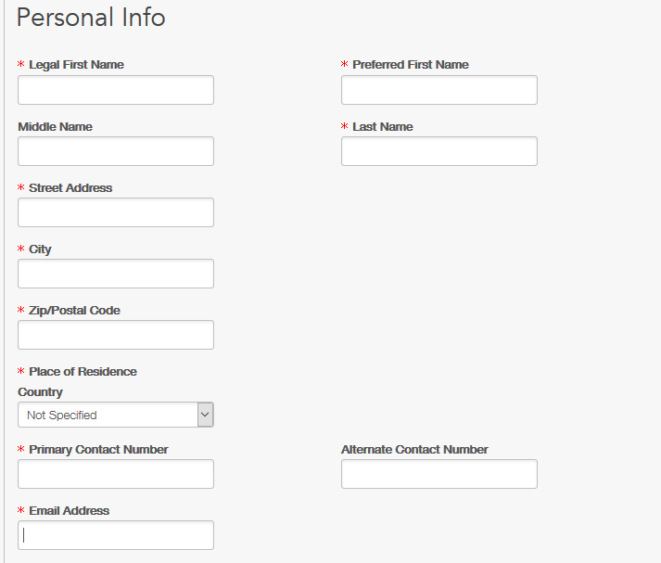
______/5
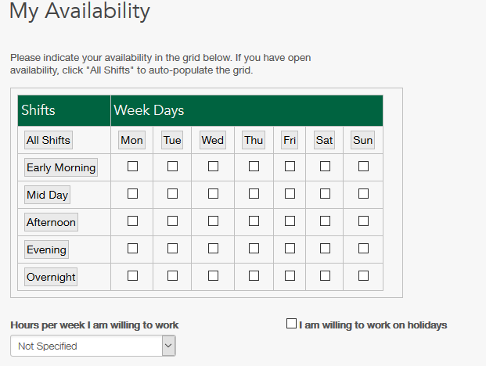
______/7

Listening (15 minutes)
  - Listen to a supervisor tell employees about the safety equipment they need to use. Circle the FOUR items that the employees must use. Put an X over the TWO items that the supervisor says are NOT necessary.


  - Listen to someone talking about their future plans. Put their plans in order.
  - Ask a career advisor to check my resume.
  - Write a resume.
  - Apply for a job installing flooring.
  - Take the Language for Work course to get experience and a reference
  - Hire other newcomers.
  - Look online for a job installing flooring.
  - Start my own flooring company.
______/13
(Plus the points from the listening section of the Job Interview) _____/6
Writing (30 minutes)
Choose one of the following tasks. Write a paragraph on the next page.

Task: Describe a job you did in the past. You can write about a job you did in your home country, or a job you did in Canada.

OR

Task: Your friend wants to find a job. What should he or she do? Give him or her some suggestions. (Your friend may be in Canada. Or your friend may be another country you know about.)

__________________________________________________________________________________________________________________________________________________________________________________________________________________________________________________________________________________________________________________________________________________________________________________________________________________________________________________________________________________________________________________________________________________________________________________________________________________________________________________________________________________________________________________________________________________________________________________________________________________________________________________________________________________________________________________________________________________________________________________________________________________________________________________________________________________________________________________________________________________________________________________________________________________________________________________________________________________________________________________________________________________________________________________________________________________________________________________________________________________________________________________________________________________________________________________________________________________________________________________________________________________________________________________________________________________________________________________________________________________________________________________________________
Writing Rubric:
Instructions for completing the rubric.
For each row, circle the description that best describes the student’s writing. If the student does not completely meet the description, give partial points. For instance, if a student only writes 3 complete sentences, you should give 1 point under “task.” Add up the points for a total score.
Holistic | - Message can be understood by reader with some difficulty.  3 | - Message can be mostly understood by reader.  4 | - Message can be easily understood by reader.  5
Task | - Writes a minimum of 5 complete sentences (including a subject and verb).  3 | - Writes a loosely organized paragraph  - Conveys main ideas supported with some detail.  4 | - Writes a paragraph that includes an introduction, development, and conclusion.  - Provides accurate descriptions and enough supportive details.  - Uses appropriate connective words.  5
Vocabulary | - Developing range of simple everyday vocabulary  - Makes minimal use of work-related vocabulary  3 | - Adequate range of simple everyday vocabulary  - Uses some work-related vocabulary  4 | - Adequate range of vocabulary for task  - Makes good use of work-related vocabulary (although may still have awkward sounding phrases and word combinations)  5
Analytic language and writing | - Developing control of  - Spelling  - Punctuation  - Capitalization  - Developing control of simple structures  - Writing in simple sentences.  - Difficulty with word order and word forms interferes with comprehension.  3 | - Adequate control of  - Spelling  - Punctuation  - Capitalization  - Adequate control of simple structures. Uses some coordinated clauses with basic tenses.  - Difficulty with word order and word forms may interfere with comprehension.  4 | - Adequate control of  - Spelling  - Punctuation  - Capitalization  - Paragraph format  - Good control of simple structures  - Attempts complex structures (with difficulty)  5
_________/20
Speaking: Job interview (10 minutes per student)
Interview script | Score Listening for 2 questions in each section. |  | Score speaking for the BEST response in each section.
Hello, I’m ___.  And you are...?  Shake hands.  It’s nice to meet you.  Let’s start off with an easy question. | Does the response indicate understanding of the question? |  | 0=Does not attempt to answer (or was not asked a question in this section)  1=Makes an attempt, but is unable to answer questions.  2=Barely answers questions; answers in phrases and some short sentences.  3=Answers questions in 4-5 short sentences with some discourse connectors. Limited vocabulary. Slow, with pauses and hesitations.  4=Answers questions in short sentences and some longer compound sentences. Adequate vocabulary to convey meaning. Slow to normal speech rate.  5=Responds appropriately to question intent. Uses connected discourse; adequate range of everyday vocabulary; some topic-specific vocabulary; some idiomatic usages; good control of simple structures; some control of complex structures.
Tell me about yourself.  What skills do you have? | YES  YES | NO (or not attempted)  NO (or not attempted)
Why should we hire you?  Why do you want this job?  What is your greatest weakness? Explain. | YES  YES | NO (or not attempted)  NO (or not attempted)
How would your coworkers (or references) describe you?  Where do you see yourself in 5 years?  How do you handle conflict? | YES  YES | NO (or not attempted)  NO (or not attempted)
Thank you for coming in today. We will get back to you once we’ve made a decision.  Goodbye. | Listening Score:  _______/6 |  | Speaking score  _______/15

Instructions for the Speaking portion of the PrePost Test:
Scoring the Listening:
Ask two questions in each section. It is OK to repeat a question one time if requested, but do not offer synonyms or clarification. Just move on to the next question if the student does not understand.
- Circle YES for each question in a section that the student understands (maximum of 2 YES answers per section). Circle NO if student does not understand the question.
- Give one point for each YES.
- These listening scores should be added to the Listening section of the test.

Scoring the Speaking:
For each section, give ONE score (0-5) that describes the student’s BEST answer to the questions in that section. That is, if the student minimally answers one question in a section, but gives a substantial answer to the next in the same section, give a score based on the more substantial answer.
If a student cannot answer one question, go on to the next question. If the student cannot answer that next question, then end the test by thanking them for coming in to the job interview.
The sections and descriptors conform generally to a CLB level (3/4/5). However, for the purposes of this PrePost test, you should give learners a score rather than a CLB level.

Listening transcripts
Listening 1 Transcript
Hello everyone. Glad you could make it out here to the West Gate construction site this morning. OK. Alright. First things first. I want to make sure everyone is wearing the required safety equipment today. So, the entire time you are on the site, you absolutely MUST be wearing a hard hat and a safety vest. You also need to wear steel toed boots. And you will also need your safety glasses.
OK. Um. Also. Today I DON’T want you to wear any hearing protection. So that means, no ear plugs; no ear muffs. Nothing over your ears. It’s important that you are able to hear any warning bells and announcements.
OK. Alright! Let’s get to work!
Listening 2 Transcript
My name is Fuad. I’m 35 years old. I used to install flooring in my country. I came to Canada one year ago, and I need to find a job to support my family. My first step is to take the Language for Work course. That’s what I’m doing now! This course will help me to get some Canadian experience and a Canadian reference. After I finish the Language for Work course, I will write a resume. I will take my resume to a career adviser at NorQuest College. He or she will check it for me. Then I will do a search online for a job installing flooring. I will apply for jobs installing flooring. In a few years, I hope to start my own flooring company. I will be able to hire other newcomers and help them get jobs.

Information and picture from https://alis.alberta.ca/occinfo/occupations-in-alberta/occupation-profiles/auto-detailer/
Transcripts at end of document
The first column in the rubric loosely matches CLB 3 descriptors, the second column matches CLB 4 descriptors, and the third matches CLB 5 descriptors. However, for the purpose of this PrePost test, you do not need to determine a particular CLB level. Just give a numerical score.

