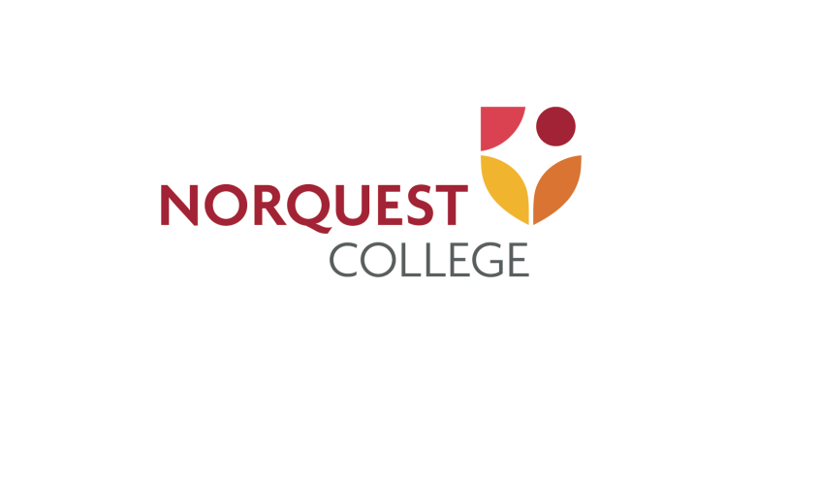

Language Integration and Workforce Training
Public Report

Job Skills Training and Labour
Government of Alberta

Date: February 25, 2019

Submitted by:
Dorte Weber
Foundational, Career, and Intercultural Studies

Prepared by:
Wendy Ilott and Dorte Weber
Foundational, Career, and Intercultural Studies

Need for Language for Work
Alberta’s workforce is aging and the number of people in the working years continues to decrease. One of the many reasons that Canada welcomes immigrants and refugees is that they bolster our working population. However, newcomers to Alberta continue to struggle to find employment. The most at-risk group of unemployed newcomers is low-level English language speakers and literacy leaerners. As it can be challenging to find suitable work for this group of learners, most EWP programs are oriented to newcomers with higher language levels. The number of opportunities for our most vulnerable ELL population is very limited. The present project responds to this need by developing a curriculum and teaching materials to prepare CLB 3-5 ELLs to access employment.

Response to the need
With funding from Settlement and Language Programs, Alberta Labour, NorQuest College developed the Language for Work course. This course is a new opportunity for CLB 3-5 English Language Learner (ELL) participants to learn about career planning, finding a job, and workplace culture through focussed study and job shadowing. Participating employers in Edmonton also benefited from the project, increasing their confidence and ability to integrate newcomer staff into their place of business.

Overview of the project
The Language for Work Project consists of four distinct phases.

2017 – Phase One
The first phase, curriculum development, resulted in 100-hours of integrated English-workforce training called Language for Work. It features competency-based language tasks designed around workplace themes and content, including employment preparation, basic intercultural training, and workplace essential skills. One of the features of the program is a work placement that is designed to help participants create an individualized career plan for their future.
As the curriculum was finalized, the course was marketed in the Edmonton area through the development and distribution of marketing materials, presentations to immigrant serving organizations and other language training programs. The course was also marketed internally through presentations to students and student service staff.

January – April 2018 – Phase Two
The second phase, the initial pilot, involved two classes. One piloting class was LINC – CLB 3-4 and the other piloting class was LINC – CLB 5L (Literacy). From the initial pilot, we confirmed that the curriculum materials are level/ content appropriate,and the participants were successful in acquiring the content and skills expected. Through work placements, participants learned about the Canadian workplace expectations, workplace culture, and job opportunities. Participating employers improved their confidence in hiring and integrating newcomer staff.

May – August 2018 – Phase Three
Based on feedback from the first pilot, the curriculum was revised. The original course developers created an interactive multimedia soft skills module that relates to critical incidents from the first pilot.

September – December 2018 – Phase Four
The fourth phase consisted of a revised offering and a second pilot. Rather than a multiple week job placement, participants completed two job shadows, which allowed a greater variety of placements more suited to the participants’ long-term career plans. The second pilot was conducted within an ESL CLB 4 class. The job shadow experience supplements the learners’ cultural capital because with aspirational job shadows, they can envision a future career path and the steps they can take to get there. Learners completed the program with clearer, realistic goals and the motivation to reach their goals.

Project Outcomes
The expertise from this project benefits the whole immigrant-serving community. The teaching materials and process for creating the Language for Work course were shared at the ATESL 2018 conference and will be shared at the Literacy and Learning Symposium in September 2019. Immigrant serving organizations such as AWES, LARCC, CALPs and other settlement or language training groups were also given the materials or made aware of the availability of the materials.
Learners, teachers, and employers benefitted from the Language for Work Experience. 100% of the employer focus group participants reported that in the future they are willing to hire a newcomer with low-level English skills and many felt that they were better prepared to onboard ELL workers. Teachers were satisfied with the curriculum materials and advocated that they be integrated into regular programming. Finally, the learners rated the final version of the program extremely highly and recommended that it become more available in the future. All of the stakeholders expressed the desire to be involved with the program again.
At its core, Language for Work provides practical and meaningful opportunities to communicate about work. Learners were able to use these opportunities to evaluate the suitability of a career choice or simply to improve their English in authentic settings. Employers learned about how to work with low-level language learners and these learners’ potential as future employees. The Language for Work program succeeded in raising learners’ language level while educating them about workplace culture in Alberta.

Service Canada (2018). Environmental Scan - Alberta: Spring 2017. Retrieved from https://www.jobbank.gc.ca/content_pieces-eng.do?cid=12072&lang=eng&wbdisable=true

